**User Story #4 (Chrome Mobile)**

**Steps**

1. Land on <https://www.carnival.com>

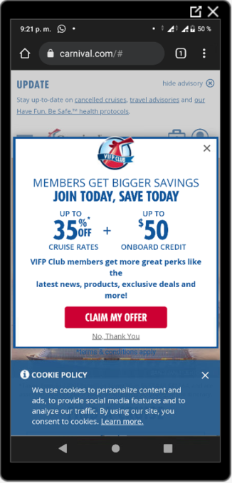

1. Verify land on Carnival
2. Close offer modal

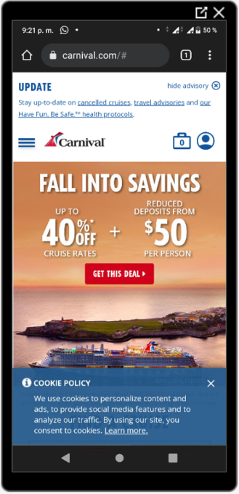

1. Close cookie banner

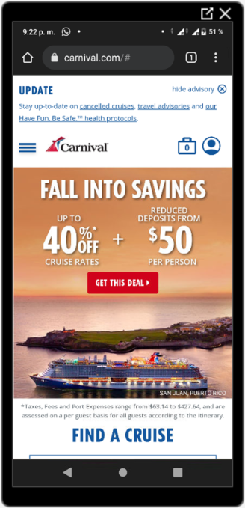

1. Verify that a link is displayed in the footer of the page.

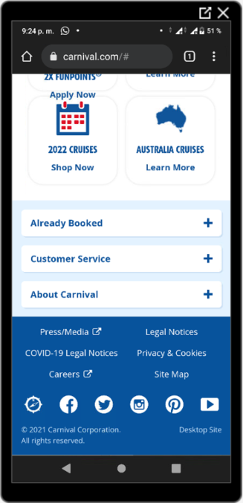

1. Touch on the link.
2. Touch in contact us.

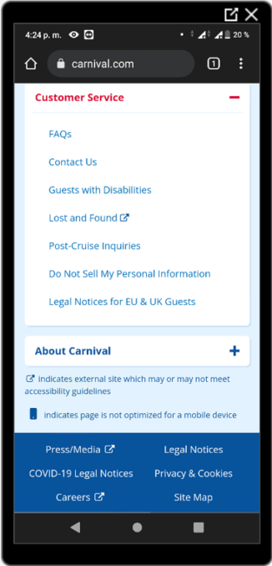

1. Verify the link is open in a new tab.

